Alcohol is a drug classified as a depressant, meaning it will slow down your vital functions. Alcohol is also a toxin, meaning it’s a type of poison.

THE
DRUG WAVE

ALL ABOUT THE DRUGS WE DEAL WITH

HAVE YOU SEEN THIS DRUG?

Alcohol

This drug’s name is Alcohol, if you run into him… GET AWAY AT ALL COST! Extremely Dangerous. 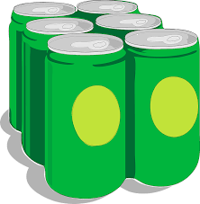

If you’re an underage drinker you should stop now. If you don’t feel like stopping yet, please listen to this at least. If you are drinking a lot and think you’re going to die, call authorities for help. Good Samaritan Law prevents a caller from being persecuted for underage drinking if they call for help. So if you or your friend is having trouble, call in and you and the buddy in trouble will be safe.

Shrek the Musical!!

Come see Shrek the Musical today, you’ll be able to see the handsome ogre go on his journey to save the princess and more. It’s even more magical then Harry Potter, Just don’t let your memes be dreams.

Alcohol Statistics
Mental/Emotional Effects of Alcohol
Physical effects of Alcohol

Alcohol affects you physically very bad, if you over drink too much you could die from it. Of course death is the worst affect, but that’s only if you over drink a lot, or other effects pile on each other. Those affects could be vomiting, unconsciousness, slurred speech, loss of bladder control, or violence. Basically drinking alcohol messes with your brain in a bad way, which could affect you physically.

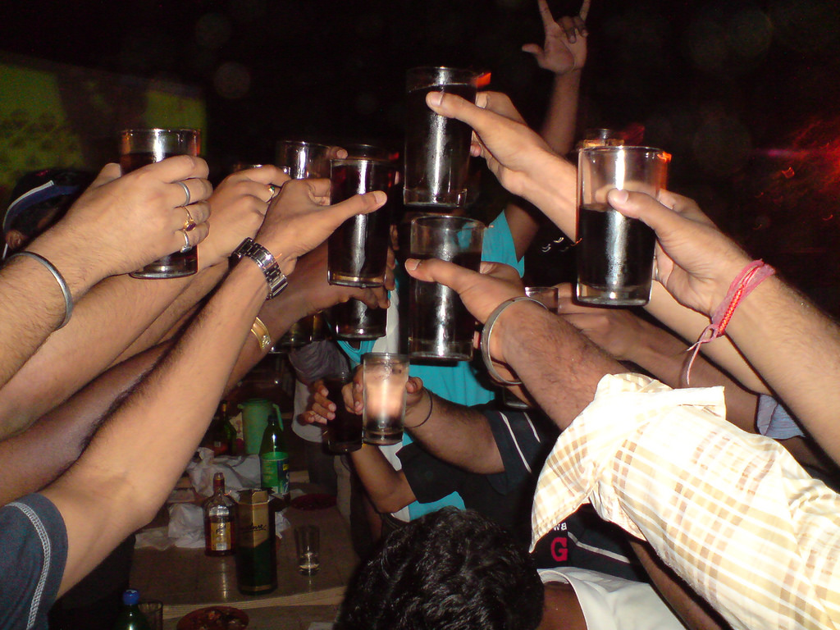
Addiction I think would be one of the worst effects to gain. If you get addicted to alcohol, then that could lead to a lot worst effects like death (physical effect). Some more effects are anxiety, or depression.

Alcohol effects the brain in many ways, whether it be addiction, oppression, or mood swings.

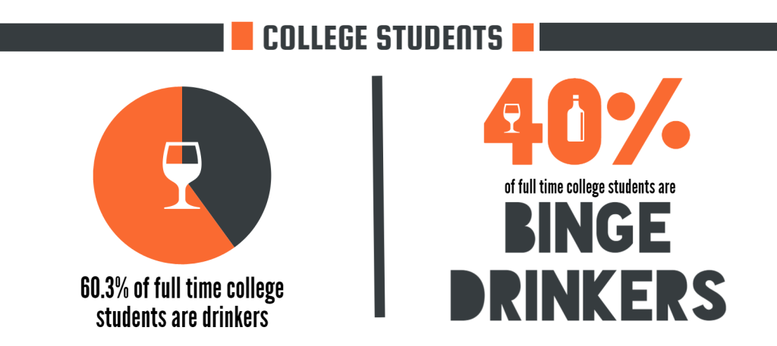
Binge drinking is where you drink a lot of alcohol in one sitting, an estimated 88,000 deaths happen from alcohol related things annually. To go with that, there is an estimated 1825 college student deaths from alcohol each year.
Immediate/Short effects
Long effects

- Brain Damage
- Depression
- Liver Disease
- Pancreatic Disease
- Death
- Coma

- Slurred Speech
- Nausea
- Vomiting
- Loss of Bladder Control
- Unconscious
- Sleepiness
- Breathing dificultys

- https://www.collegedrinkingprevention.gov/Statistics/consequences.aspx
- https://www.niaaa.nih.gov/alcohol-health/overview-alcohol-consumption/alcohol-facts-and-statistics
- https://shrekthemusical.co.uk
Sources

